How to use NGSPICE

Introduction:
NGSPICE is a widely used circuit simulator, which can be used to model and observe the behavior of linear and nonlinear circuits. NGSPICE contains a library of basic circuit components and ideal/commonly used models of various semiconductor devices. The user has the flexibility to include specific device libraries and can define their own libraries as well.
NGSPICE provides multiple platform compatibility; it can be on both Linux and Windows operating systems. You can download the NGSPICE setup and manual from the link:
http://sourceforge.net/projects/NGSPICE/files/ng-spice-rework/old-releases/21/NGSPICE21_100620.zip/download
- Installing and Working with NGSPICE (in Windows):
- For using in windows, first extract the “NGSPICE21_100620.zip” file at desired location. It should contain two main folders as “bin” and “lib”, and apart from those it contains other folders such as “doc”, “examples”, etc.
- You need to work with the “NGSPICE.exe” which is located inside the “bin” folder. By executing this “NGSPICE.exe” a GUI opens up, which is used for entering various NGSPICE commands. For running a simulation you need to specify a “.cir” or “.spice” file (and the path as well) through this GUI. The “.cir” or “.spice” file should contain elemental lines describing the circuit to be simulated.

The “.cir” or “.spice” file:
For simulating any circuit in NGSPICE we need to write some lines which contain node and element descriptions, this description is known as a circuit netlist. These lines direct the simulator to interpret the circuit elements and the kind of analysis to be performed. There are several rules (refer to NGSPICE manual) which govern the description of “.cir” OR “.spice” files in order for correct simulations.

Some notes regarding writing “.cir” or “.spice” file:
- First line in “.cir” or “.spice” file is used to represent title or brief description of the circuit to be simulated. This line is never executed.
- The syntax for describing circuit elements are as follows:
<Element> <nodes between which element come> <value>
- For every element we can create a model which has its specific technical characteristics, otherwise the simulator takes default or ideal device characteristics.
- Every commented line begins with a “*”.
- For ending the netlist, use “.end” command.
In NGSPICE we also have facility for generating plots of various analyses, and after that we can also save that as “.ps” i.e. postscript file in colour or b/w formats.

Writing a “.cir” or “.spice” file:
Let us consider an example explained in stepwise procedure,
Aim of the simulation: To study the I/V characteristics of a simple diode circuit.
For that purpose we need a circuit diagram which helps us in getting better nodal and elemental description.
Figure 1. Diagram for diode circuit:
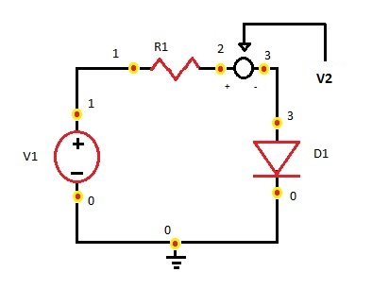
Circuit shows a simple diode circuit, with node description.
Here an extra voltage source (initialized with zero voltage) “V2” placed between node 2 and 3. In NGSPICE we use zero initialized voltage sources for measuring current between two nodes (here between node 2 and 3).
NGSPICE netlist for obtaining I/V characteristics using diode circuit shown above:

DIODE CHARACTERISTICS
*above line used for declaring title i.e. first line of “.cir” or “.spice” file
.MODEL DIO D( IS=1.8E-14 RS=2 BV=50.0 IBV=1e-4
+ CJO=2e-12 M=0.333 N=2.06 TT=4.32e-9)
*above line declares the diode model used, due to this model we got a cut in voltage of 1.2 volt instead of .7 volt.
*then writing elementals description
D1 3 0 DIO
R1 1 2 100
V1 1 0 dc 0v
V2 2 3 dc 0
*from here we are going to perform a dc analysis
.dc v1 0 5 0.2
.control
Run
*then put command for plotting current/voltage curve
plot i(V2) vs v(3)
.endc
.end
*above line shows closing of all simulation analysis
For better understanding these commands go through NGSPICE manual.

Screenshots:

Figure 2. UI of NGSPICE

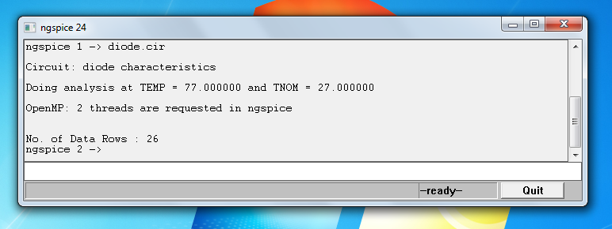

Figure 2. Entering the “.cir” or “.spice” file

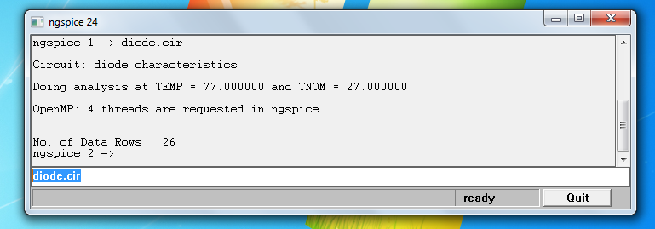

Figure 4. Output of simulation

